## User Interface Design

### Guest Interface Design

#### Login

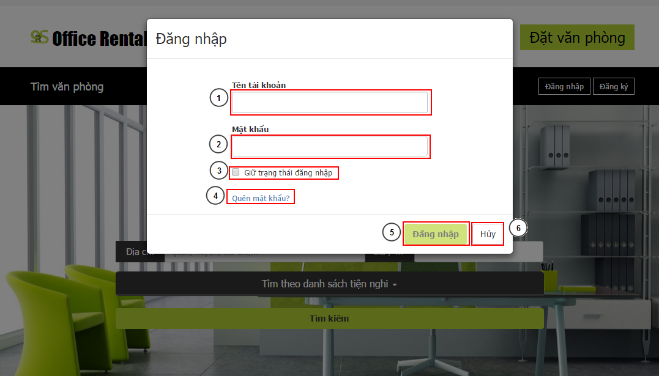

Figure 1: Login

**Fields**

|  |  |  |  |  |  |  |  |
| --- | --- | --- | --- | --- | --- | --- | --- |
| **No** | **Field Name** | **Description** | **Read only** | **Mandatory** | **Control Type** | **Data Type** | **Length** |
| 1 | Username | Username for customer to login | No | Yes | Textbox | String | [3-50] |
| 2 | Password | Password for login | No | Yes | Password | String | [1-50] |

**Buttons/Hyperlinks**

|  |  |  |  |  |
| --- | --- | --- | --- | --- |
| **No** | **Function** | **Description** | **Validation** | **Outcome** |
| 3 | Remember me | Store the login info to client to remember next login | N/A | Choose to remember the login info for the next time user go to website |
| 4 | Forget password | Link to forget password page | N/A | Go to forget password page |
| 5 | Login | Login to website | Yes | Login and close popup |
| 5 | Back | Cancel login and back | N/A | Close login popup |

#### Search Office list

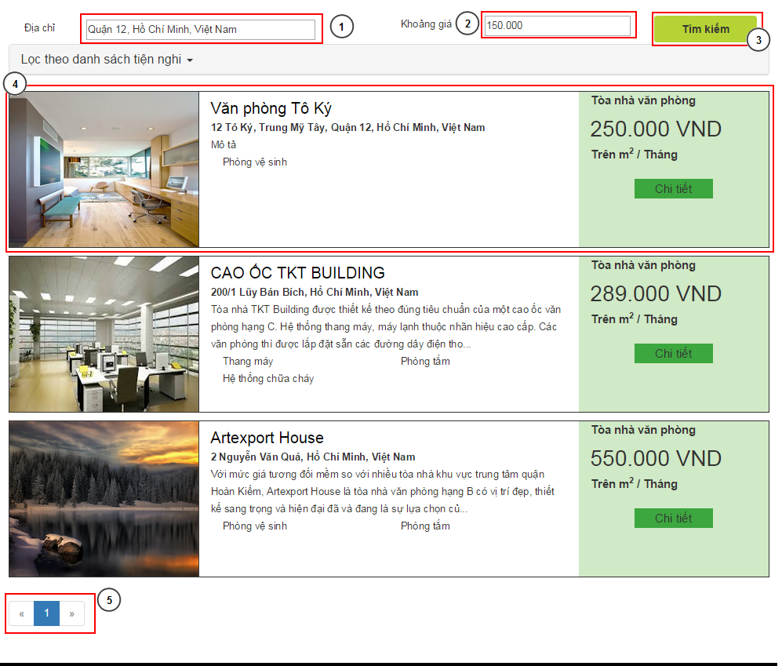

Figure 2: Search office list

**Fields**

|  |  |  |  |  |  |  |  |
| --- | --- | --- | --- | --- | --- | --- | --- |
| **No** | **Field Name** | **Description** | **Read only** | **Mandatory** | **Control Type** | **Data Type** | **Length** |
| 1 | Address | Address for search | No | Yes | Textbox | String | N/A |
| 2 | Price Range | Price range for search | No | No | Textbox number | Long | N/A |
| 4 | Office Info | Information of office | Yes | No | Image + Text field | N/A | N/A |

**Buttons/Hyperlinks**

|  |  |  |  |  |
| --- | --- | --- | --- | --- |
| **No** | **Function** | **Description** | **Validation** | **Outcome** |
| 3 | Search | Do the search again | Yes | Refresh the search list with the input info |
| 4 | Office Info | Link to office detail | N/A | Click on image, the title of office, “Chi tiết” button will transfer to office detail page |
| 5 | Paging | Paging for office list | N/A | Transfer between pages in office search list |

#### Request appointment

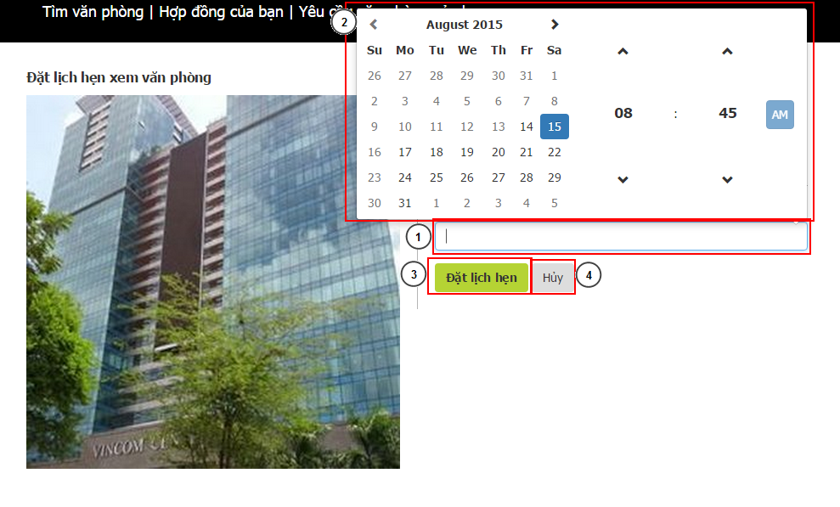

Figure 3: Request appointment

**Fields**

|  |  |  |  |  |  |  |  |
| --- | --- | --- | --- | --- | --- | --- | --- |
| **No** | **Field Name** | **Description** | **Read only** | **Mandatory** | **Control Type** | **Data Type** | **Length** |
| 1 | DateTime | Date and time for appointment | No | Yes | Textbox | DateTime | N/A |

**Buttons/Hyperlinks**

|  |  |  |  |  |
| --- | --- | --- | --- | --- |
| **No** | **Function** | **Description** | **Validation** | **Outcome** |
| 2 | DateTime Selection | The selection for date and time | Yes: valid date | Change the value of DateTime textbox |
| 3 | Request | Request new appointment | Yes: valid date | Request a new appointment on current office at the selected time |
| 4 | Cancel | Cancel the request | N/A | Go back to office detail page |

### Manager Interface Design

#### View Calendar

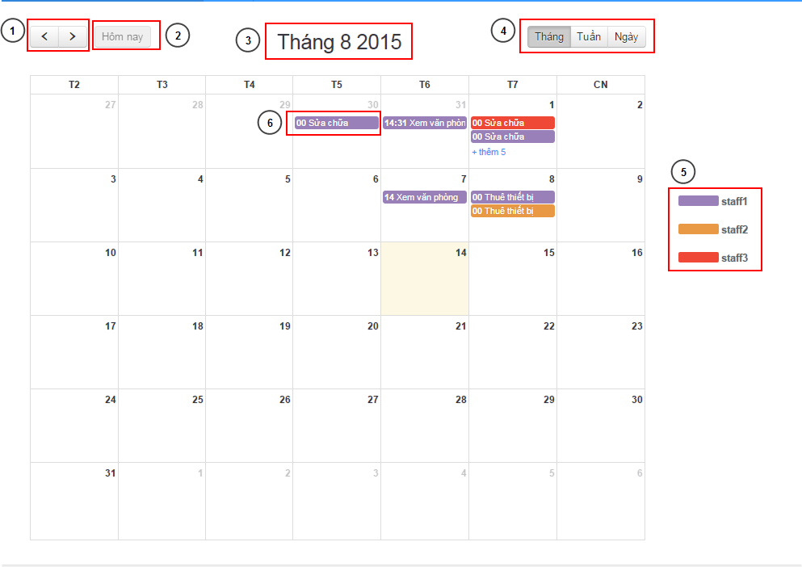

Figure 3: View calendar

**Fields**

|  |  |  |  |  |  |  |  |
| --- | --- | --- | --- | --- | --- | --- | --- |
| **No** | **Field Name** | **Description** | **Read only** | **Mandatory** | **Control Type** | **Data Type** | **Length** |
| 3 | Current time | The current selection time | Yes | N/A | Label | String | N/A |
| 5 | Legends | The legends for staff with color | Yes | N/A | Label with color | String | N/A |

**Buttons/Hyperlinks**

|  |  |  |  |  |
| --- | --- | --- | --- | --- |
| **No** | **Function** | **Description** | **Validation** | **Outcome** |
| 1 | Navigation | Navigation the calendar | N/A | Go to next or previous period of time (select by (4) ) on calendar |
| 4 | Time period | The period to display the calendar in | N/A | Change the value will display the calendar with selected period of time |
| 6 | Job link | Link to selected job | N/A | Go to the job (appointment/ repair/rental) detail |

#### View office list

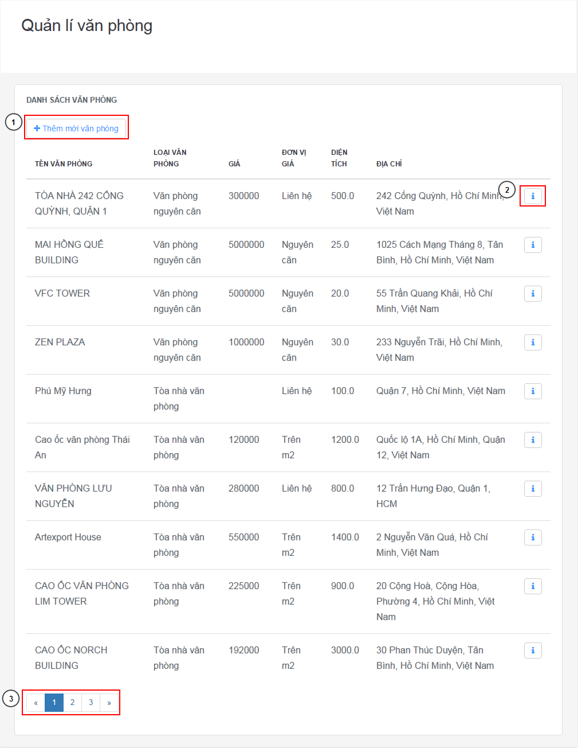

Figure 3: View office list

**Fields**

|  |  |  |  |  |  |  |  |
| --- | --- | --- | --- | --- | --- | --- | --- |
| **No** | **Field Name** | **Description** | **Read only** | **Mandatory** | **Control Type** | **Data Type** | **Length** |
| 0 | Office Table | Abstract information of the office | Yes | N/A | Table | String | N/A |

**Buttons/Hyperlinks**

|  |  |  |  |  |
| --- | --- | --- | --- | --- |
| **No** | **Function** | **Description** | **Validation** | **Outcome** |
| 1 | New office | Link to new office page | N/A | Go to add new office page |
| 2 | Office detail | Link to office detail | N/A | Go to current office detail page |
| 3 | Paging | Paging of office table page | N/A | Change the page of office table |

#### Add new office

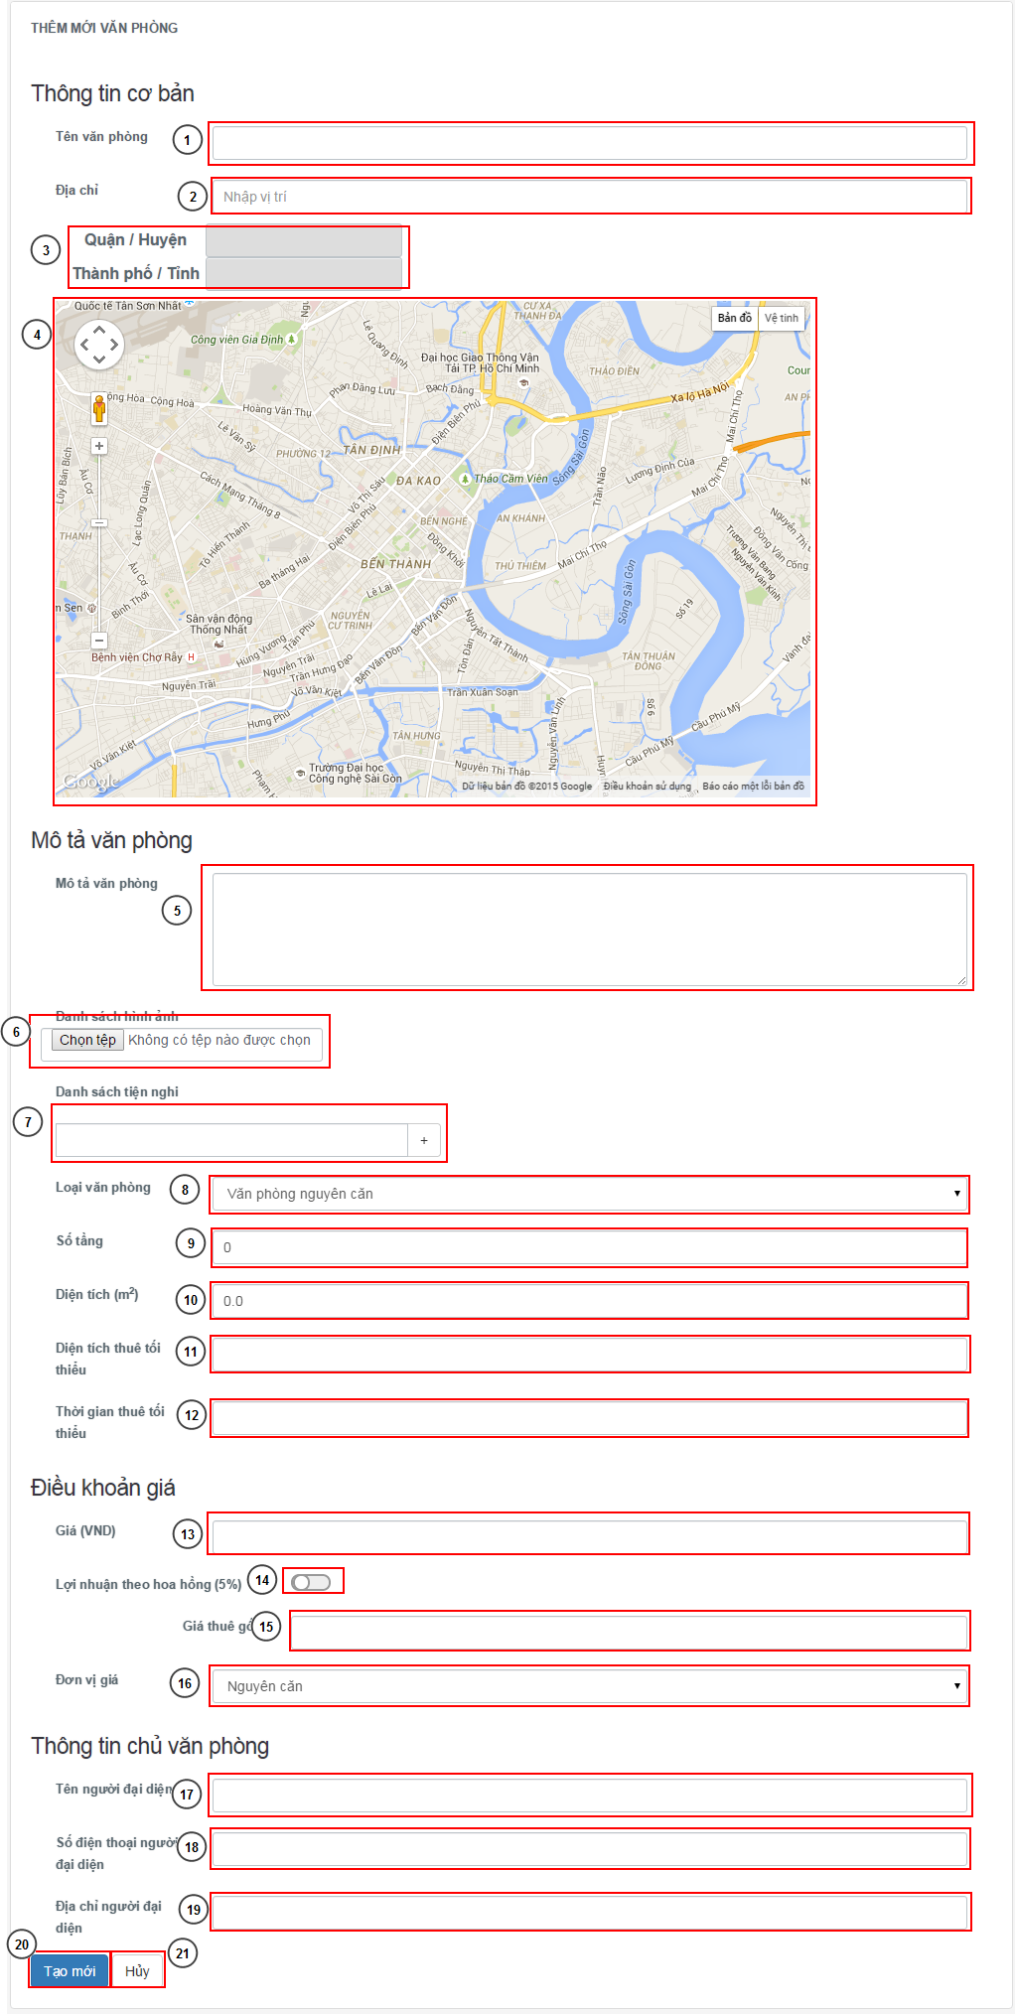



Figure 3: Add new office

**Fields**

|  |  |  |  |  |  |  |  |
| --- | --- | --- | --- | --- | --- | --- | --- |
| **No** | **Field Name** | **Description** | **Read only** | **Man-datory** | **Control Type** | **Data Type** | **Length** |
| 1 | Office name | Name of the office | No | Yes | Textbox | String | [5-150] |
| 2 | Address | Address of the office | No | Yes | Textbox | String | [5-150] |
| 3 | Address detail | The district and city of input address | No | Yes | Textbox | String | N/A |
| 5 | Description | Description of the office | No | Yes | Text area | String | Unlimited |
| 7 | Amenity input | Input the amenity | No | No | Textbox | String | [1-150] |
| 8 | Office type | Type of the office | No | Yes | Drop-down | String | N/A |
| 9 | Floor number | Number of floor | No | Yes | Textbox number | Integer | [1-3] |
| 10 | Area | Total area of office | No | Yes | Textbox number | Float | [1-9] |
| 11 | Min area | The minimum area customer can rental | No | Yes (only building office type) | Textbox number | Float | [1-9] |
| 12 | Min time | Minimum time customer can rental in month | No | Yes | Textbox number | Integer | [1-3] |
| 13 | Price | The price of the office | No | Yes when price term is not call | Textbox number | Long | [0-15] |
| 14 | Is percent | Will company take income as percent of rental price or by offer price | No | Yes | Check box | N/A | N/A |
| 15 | Base price | Base price, will display when Is percent is set to off | No | Yes | Textbox number | Long | [0-15] |
| 16 | Price term | The term of the price (by all office, in m2 or call) | No | Yes | Drop down box | N/A | N/A |
| 17 | Owner name | Name of owner of the office | No | Yes | Textbox | String | [5-150] |
| 18 | Owner phone | Phone of owner of office | No | Yes | Textbox | String | [9-11] |
| 19 | Owner address | Address of owner of office | No | No | Textbox | String | [5-150] |

**Buttons/Hyperlinks**

|  |  |  |  |  |
| --- | --- | --- | --- | --- |
| **No** | **Function** | **Description** | **Validation** | **Outcome** |
| 4 | Map | The map for current address | N/A | Change when the address change |
| 6 | Images | Button for upload images | Yes, image type only | Open upload windows. Add image at above, each has remove button |
| 7 | Add amenity | Press enter or button “+” to add amenity | N/A | Add new amenity based on info in textbox |
| 20 | Create | Create new office | Yes | Validate and create new office |
| 21 | Cancel | Cancel create office | N/A | Cancel and go back to office manage page |

#### Office detail

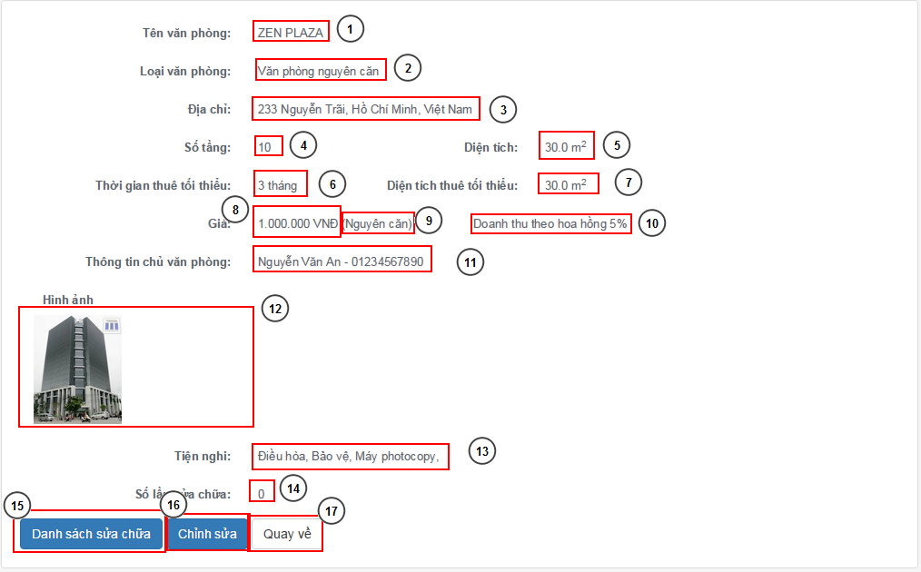

Figure 3: Office detail

**Fields**

|  |  |  |  |  |  |  |  |
| --- | --- | --- | --- | --- | --- | --- | --- |
| **No** | **Field Name** | **Description** | **Read only** | **Mandatory** | **Control Type** | **Data Type** | **Length** |
| 1 | Office name | Name of office | Yes | N/A | Text field | String | N/A |
| 2 | Office type | Type of the office | Yes | N/A | Text field | String | N/A |
| 3 | Address | Address of the office | Yes | N/A | Text field | String | N/A |
| 4 | Floor number | Number of floor | Yes | N/A | Text field | Integer | N/A |
| 5 | Area | Area of the office | Yes | N/A | Text field | Float | N/A |
| 6 | Min time | Minimum month for rental | Yes | N/A | Text field | Integer | N/A |
| 7 | Min area | Minimum area for rental | Yes | N/A | Text field | Float | N/A |
| 8 | Price | Price of rental | Yes | N/A | Text field | Long | N/A |
| 9 | Price term | Term of rental price | Yes | N/A | Text field | Integer | N/A |
| 10 | Income type | Type of income | Yes | N/A | Text field | Integer | N/A |
| 11 | Owner info | Information of office owner | Yes | N/A | Text field | Integer | N/A |
| 12 | Images | Images of office | Yes | N/A | Text field | Image | N/A |
| 13 | Amenity list | List of amenity | Yes | N/A | Text field | String | N/A |
| 14 | Repair count | Count of repair of the office | Yes | N/A | Text field | Integer | N/A |

**Buttons/Hyperlinks**

|  |  |  |  |  |
| --- | --- | --- | --- | --- |
| **No** | **Function** | **Description** | **Validation** | **Outcome** |
| 1 | Repair list | Repair list of current office | N/A | Go to the repair list for current office |
| 2 | Edit | Edit information of current office | N/A | Go to edit page of office |
| 3 | Back | Go back | N/A | Back to office list page |

#### Income statistic

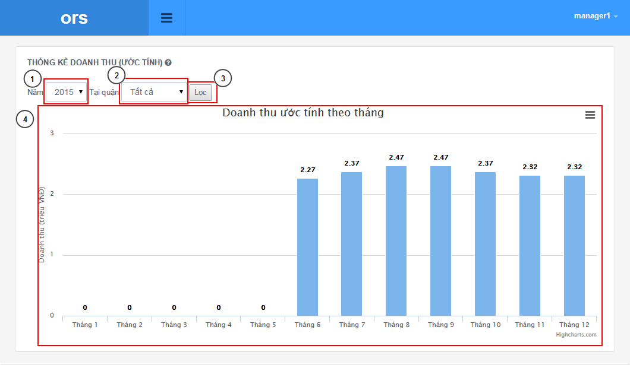

Figure 3: Income statistic

**Fields**

|  |  |  |  |  |  |  |  |
| --- | --- | --- | --- | --- | --- | --- | --- |
| **No** | **Field Name** | **Description** | **Read only** | **Mandatory** | **Control Type** | **Data Type** | **Length** |
| 1 | Year | The year of statistic | Yes | Yes | Drop down | Integer | N/A |
| 2 | District | District for statistic | Yes | Yes | Drop down | String | N/A |
| 4 | Chart | Chart of statistic | Yes | N/A | Chart | Chart | N/A |

**Buttons/Hyperlinks**

|  |  |  |  |  |
| --- | --- | --- | --- | --- |
| **No** | **Function** | **Description** | **Validation** | **Outcome** |
| 3 | Filter | Filter with selected year and district | Yes | Construct the chart for the selected filter |

#### Staff statistic

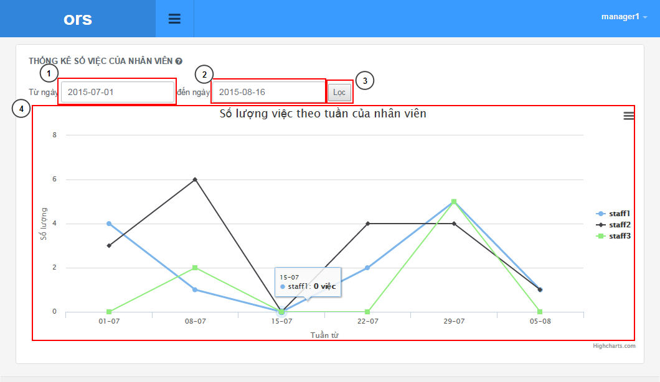

Figure 3: Staff statistic

**Fields**

|  |  |  |  |  |  |  |  |
| --- | --- | --- | --- | --- | --- | --- | --- |
| **No** | **Field Name** | **Description** | **Read only** | **Mandatory** | **Control Type** | **Data Type** | **Length** |
| 1 | From date | The date for begin of statistic | No | Yes | Textbox date | Date | N/A |
| 2 | To date | The date for end of statistic | No | Yes | Textbox date | Date | N/A |
| 4 | Chart | Chart of statistic | Yes | N/A | Chart | Chart | N/A |

**Buttons/Hyperlinks**

|  |  |  |  |  |
| --- | --- | --- | --- | --- |
| **No** | **Function** | **Description** | **Validation** | **Outcome** |
| 3 | Filter | Filter with selected year and district | Yes | Construct the chart for the selected filter |

### Mobile Interface Design

#### Login

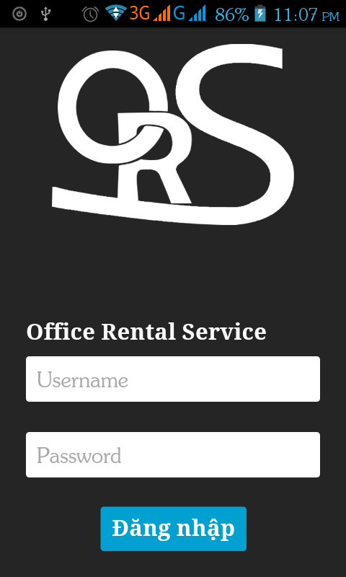

Figure 3: Login

**Fields**

|  |  |  |  |  |  |  |  |
| --- | --- | --- | --- | --- | --- | --- | --- |
| **No** | **Field Name** | **Description** | **Read only** | **Mandatory** | **Control Type** | **Data Type** | **Length** |
| 1 | Username | Username for staff to login | No | Yes | Textbox | String | [3-50] |
| 2 | Password | Password for login | No | Yes | Password | String | [1-50] |

**Buttons/Hyperlinks**

|  |  |  |  |  |
| --- | --- | --- | --- | --- |
| **No** | **Function** | **Description** | **Validation** | **Outcome** |
| 5 | Login | Login to app | Yes | Login and go to job page |

#### Home

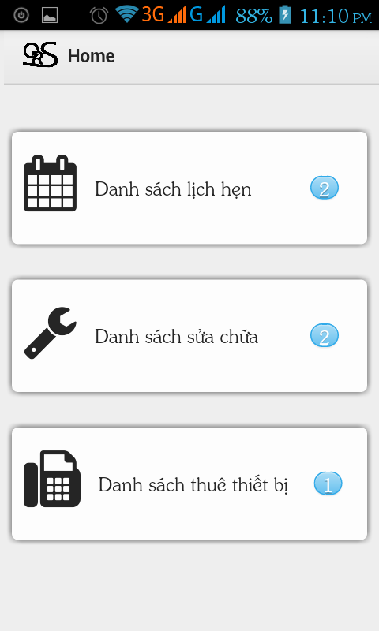

Figure 3: Home

**Buttons/Hyperlinks**

|  |  |  |  |  |
| --- | --- | --- | --- | --- |
| **No** | **Function** | **Description** | **Validation** | **Outcome** |
| 1 | Appointment list | Go to the appointment list | N/A | Go to the appointment list |
| 2 | Repair list | Go to the repair list | N/A | Go to the repair list |
| 3 | Rental list | Go to the rental list | N/A | Go to the rental list |

#### Job list

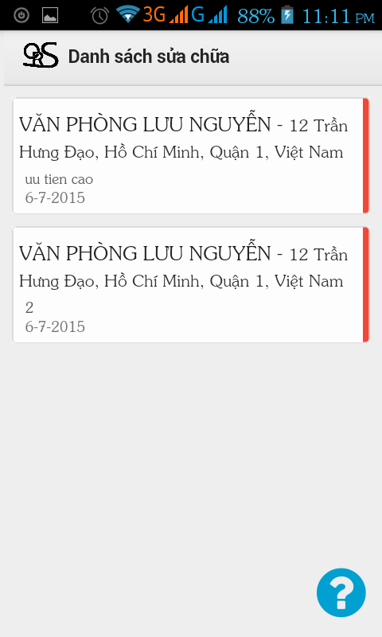

Figure 3: Job list

**Fields**

|  |  |  |  |  |  |  |  |
| --- | --- | --- | --- | --- | --- | --- | --- |
| **No** | **Field Name** | **Description** | **Read only** | **Mandatory** | **Control Type** | **Data Type** | **Length** |
| 1 | Title | Kind of job | Yes | N/A | Label | String | N/A |

**Buttons/Hyperlinks**

|  |  |  |  |  |
| --- | --- | --- | --- | --- |
| **No** | **Function** | **Description** | **Validation** | **Outcome** |
| 2 | Job detail | Go the job detail | N/A | Go to the job detail |
| 3 | Help | Help with status of job | N/A | Open a popup with color and status of job |

#### Job detail

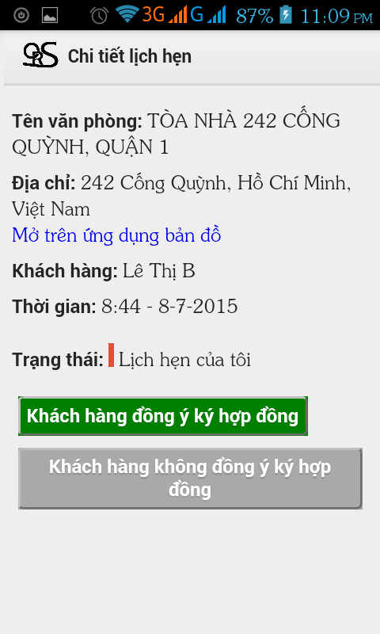

Figure 3: Job detail

**Fields**

|  |  |  |  |  |  |  |  |
| --- | --- | --- | --- | --- | --- | --- | --- |
| **No** | **Field Name** | **Description** | **Read only** | **Mandatory** | **Control Type** | **Data Type** | **Length** |
| 1 | Job info | Information of the job | Yes | N/A | Text field | String | N/A |

**Buttons/Hyperlinks**

|  |  |  |  |  |
| --- | --- | --- | --- | --- |
| **No** | **Function** | **Description** | **Validation** | **Outcome** |
| 2 | Action 1 | Change the status of job based on real status | N/A | Change the status and back to the job list page |
| 3 | Action 2 | Change the status of job based on real status | N/A | Change the status and back to the job list page |
| 4 | Map link | Link to map for current address | N/A | Open map for office address |